**Table of Contents**

**FPT APTECH**

--- o0o ---

**PROJECT REPORT**

**GREAT BARRIER REEF NATIONAL PARK**

Batch: T2108A1

Semester: 1

Group: 2

Student : Cao Quoc Trung

Student : Do The Duc

Student : Do Thi Thao

Student : Luong Trong Quoc

Student : Hoang Viet Dat

**Hanoi – 02/2022**

1. Problem Definition 3

1.1 Overview 3

i. Introduction 3

ii. Implementation Environment 3

1.2 User Stories 4

Customer 4

i. Log in 4

ii. Register 4

iii. Search by name 4

iv. View the description of each product 4

2. Follow chart 5

2.1 GUI 1: login 5

2.2 GUI 2: Register 6

2.3 GUI 3: search by names 7

2.4 GUI 4: View description of each product 8

3. UI\UX 9

3.1 Homepage 9

3.2 Categories 10

3.3 Product details 11

3.4 About us 12

3.5 Contact us 13

3.6 Feedback 14

3.7 Cart 15

3.8 Login 16

3.9 Register 17

3.10 All Brands 18

3.11 Brands Details 19

3.12 All Categories 20

4. Summary 21

**Table of Contents**

[1. Problem Definition 3](https://docs.google.com/document/d/1l6fd-97iTlC3_cDi1oBR0YUnp7yWUTYw/edit#heading=h.gjdgxs)

[1.1 Overview 3](https://docs.google.com/document/d/1l6fd-97iTlC3_cDi1oBR0YUnp7yWUTYw/edit#heading=h.30j0zll)

[i. Introduction 3](https://docs.google.com/document/d/1l6fd-97iTlC3_cDi1oBR0YUnp7yWUTYw/edit#heading=h.1fob9te)

[ii. Implementation Environment 3](https://docs.google.com/document/d/1l6fd-97iTlC3_cDi1oBR0YUnp7yWUTYw/edit#heading=h.3znysh7)

[1.2 User Stories 4](https://docs.google.com/document/d/1l6fd-97iTlC3_cDi1oBR0YUnp7yWUTYw/edit#heading=h.2et92p0)

[Customer 4](https://docs.google.com/document/d/1l6fd-97iTlC3_cDi1oBR0YUnp7yWUTYw/edit#heading=h.tyjcwt)

[i. Log in 4](https://docs.google.com/document/d/1l6fd-97iTlC3_cDi1oBR0YUnp7yWUTYw/edit#heading=h.3dy6vkm)

[ii. Register 4](https://docs.google.com/document/d/1l6fd-97iTlC3_cDi1oBR0YUnp7yWUTYw/edit#heading=h.1t3h5sf)

[iii. Search by name 4](https://docs.google.com/document/d/1l6fd-97iTlC3_cDi1oBR0YUnp7yWUTYw/edit#heading=h.4d34og8)

[iv. View the description of each product 4](https://docs.google.com/document/d/1l6fd-97iTlC3_cDi1oBR0YUnp7yWUTYw/edit#heading=h.2s8eyo1)

[2. Follow chart 5](https://docs.google.com/document/d/1l6fd-97iTlC3_cDi1oBR0YUnp7yWUTYw/edit#heading=h.17dp8vu)

[2.1 GUI 1: login 5](https://docs.google.com/document/d/1l6fd-97iTlC3_cDi1oBR0YUnp7yWUTYw/edit#heading=h.3rdcrjn)

[2.2 GUI 2: Register 6](https://docs.google.com/document/d/1l6fd-97iTlC3_cDi1oBR0YUnp7yWUTYw/edit#heading=h.26in1rg)

[2.3 GUI 3: search by names 7](https://docs.google.com/document/d/1l6fd-97iTlC3_cDi1oBR0YUnp7yWUTYw/edit#heading=h.lnxbz9)

[2.4 GUI 4: View  description of each product 8](https://docs.google.com/document/d/1l6fd-97iTlC3_cDi1oBR0YUnp7yWUTYw/edit#heading=h.35nkun2)

[3. UI\UX 9](https://docs.google.com/document/d/1l6fd-97iTlC3_cDi1oBR0YUnp7yWUTYw/edit#heading=h.1ksv4uv)

[3.1 Homepage 9](https://docs.google.com/document/d/1l6fd-97iTlC3_cDi1oBR0YUnp7yWUTYw/edit#heading=h.44sinio)

[3.2 Categories 10](https://docs.google.com/document/d/1l6fd-97iTlC3_cDi1oBR0YUnp7yWUTYw/edit#heading=h.2jxsxqh)

[3.3 Product details 11](https://docs.google.com/document/d/1l6fd-97iTlC3_cDi1oBR0YUnp7yWUTYw/edit#heading=h.z337ya)

[3.4 About us 12](https://docs.google.com/document/d/1l6fd-97iTlC3_cDi1oBR0YUnp7yWUTYw/edit#heading=h.3j2qqm3)

[3.5 Contact us 13](https://docs.google.com/document/d/1l6fd-97iTlC3_cDi1oBR0YUnp7yWUTYw/edit#heading=h.1y810tw)

[3.6 Feedback 14](https://docs.google.com/document/d/1l6fd-97iTlC3_cDi1oBR0YUnp7yWUTYw/edit#heading=h.4i7ojhp)

[3.7 Cart 15](https://docs.google.com/document/d/1l6fd-97iTlC3_cDi1oBR0YUnp7yWUTYw/edit#heading=h.2xcytpi)

[3.8 Login 16](https://docs.google.com/document/d/1l6fd-97iTlC3_cDi1oBR0YUnp7yWUTYw/edit#heading=h.1ci93xb)

[3.9 Register 17](https://docs.google.com/document/d/1l6fd-97iTlC3_cDi1oBR0YUnp7yWUTYw/edit#heading=h.3whwml4)

[3.10 All Brands 18](https://docs.google.com/document/d/1l6fd-97iTlC3_cDi1oBR0YUnp7yWUTYw/edit#heading=h.2bn6wsx)

[3.11 Brands Details 19](https://docs.google.com/document/d/1l6fd-97iTlC3_cDi1oBR0YUnp7yWUTYw/edit#heading=h.qsh70q)

[3.12 All Categories 20](https://docs.google.com/document/d/1l6fd-97iTlC3_cDi1oBR0YUnp7yWUTYw/edit#heading=h.3as4poj)

[4. Summary 21](https://docs.google.com/document/d/1l6fd-97iTlC3_cDi1oBR0YUnp7yWUTYw/edit#heading=h.1pxezwc)

# Problem Definition

## Overview

### Introduction

**Requirement Specification:**

The Web site is to be created based on the following requirements.

1. The Home Page should be created making use of Sections with a suitable logo, the header section can be added which will show images of animals.
2. The site must contain the links to navigate through any category for the information.
3. The site should display a menu which will contain the options for brief introduction about the various national parks available, location and any other information if required.
4. The web site should also provide the option of Animal Info in that particular national park page where viewers can get the information of well known animals and birds residing in that particular national park.
5. Also have a Site Map option where viewers can see what all National Parks are there in our web site and can easily know where it is situated in the country. Their location should be displayed using GeoLocation API (eg. GoogleMaps) Feedback must be allowed to enter by the viewer.
6. A brief summary of a particular national park including list of animals/birds available, other facilities at national park should be displayed on the Web Page along with the picture but detailed Features should be stored in Individual Word documents which can be downloaded or viewed by the User who wishes to see the same.

### Implementation Environment

**Hardware**

* A minimum computer system that will help you access all the tools in the courses is a Pentium 166 or better
* 64 Megabytes of RAM or better

**Software**

* Notepad/HTML editor
* Dreamweaver
* IE 5.0/ Netscape 6.0

## User Stories

## Customer

### Log in

As a customer , I want to login to the website

### Register

As a customer , I want to register to the website

### View Park’s contact details

As a customer , I want to view contact details of park

### Have a beautiful and easy-to-use interface

As a customer , I want to have a beautiful and easy-to-use interface

* + 1. Know other guest’s reviews of the park experience

As a customer, I’d like to know other guest’s reviews of the park experience

* + 1. Share my experience information about the park

As a customer, I want to share my experience information about the park

* + 1. Download a brief summary of the national park

As a customer, I want to download a brief summary of the national park

* + 1. Log out

As a customer , I want login to the website

**ADMIN**

* + 1. View guest’s information

As a admin, I want to view guest’s information

* + 1. Update information related to the park

As a admin, I want to update information related to the park

* + 1. Post information to the website

As a admin, I want to update information related to the park

* + 1. Modify information of the park
    2. Count the number of visitors and members visiting the website
    3. Log in
    4. Log out
    5. Get customer feedback

# Follow chart

## GUI 1: Contact

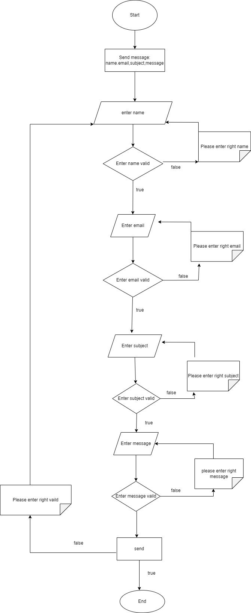

## GUI 2: Search by the name

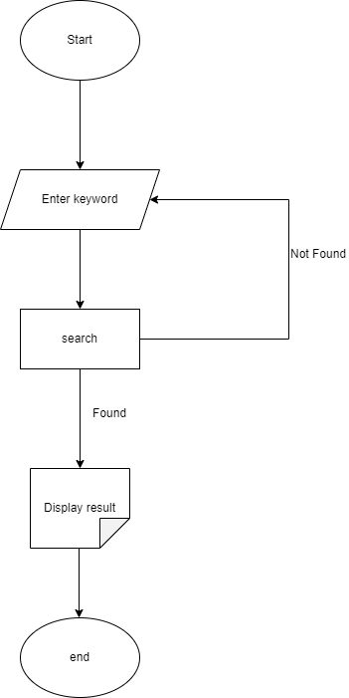

## GUI 3: Comment

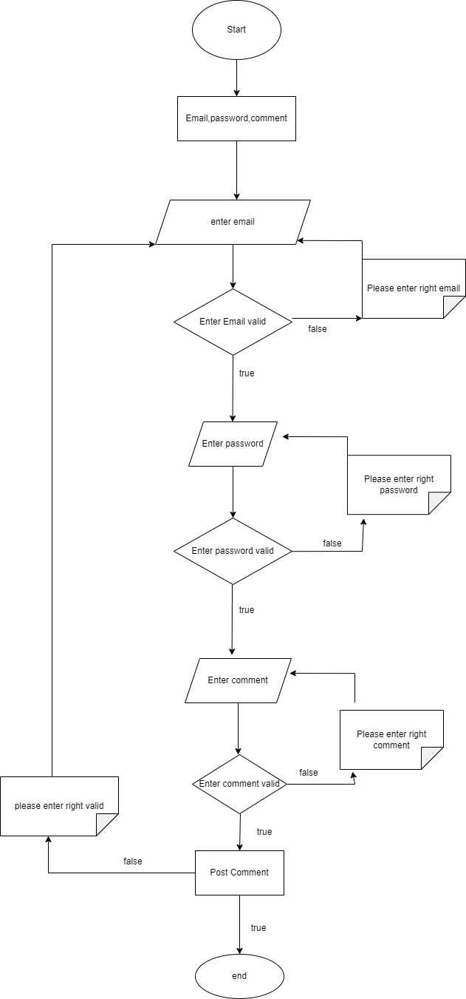

## GUI 4: Login

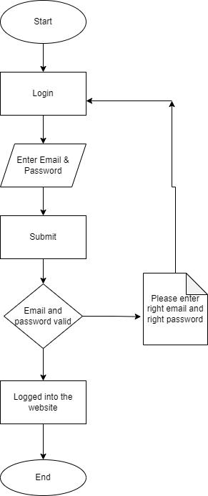

## 2.5 Register

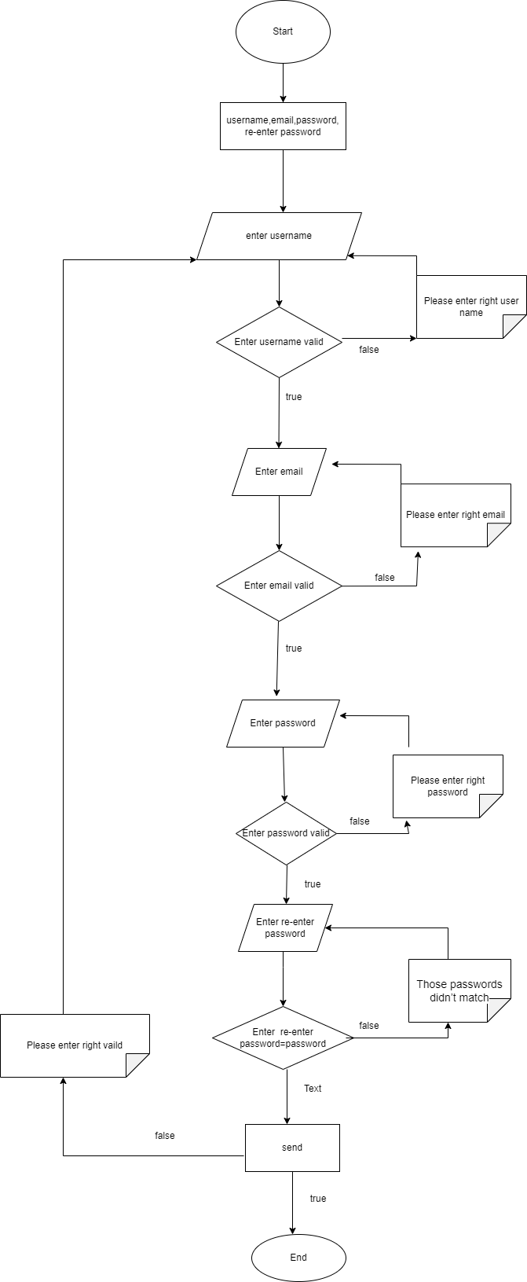

# UI\UX

## Homepage

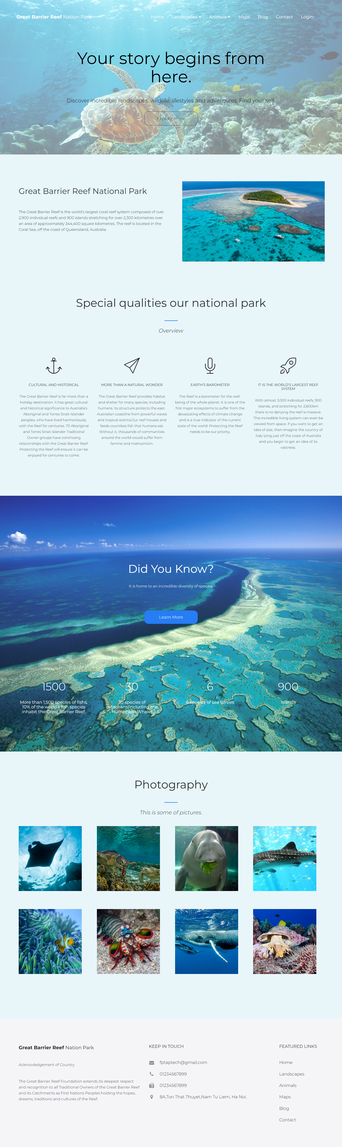

## Landscapes

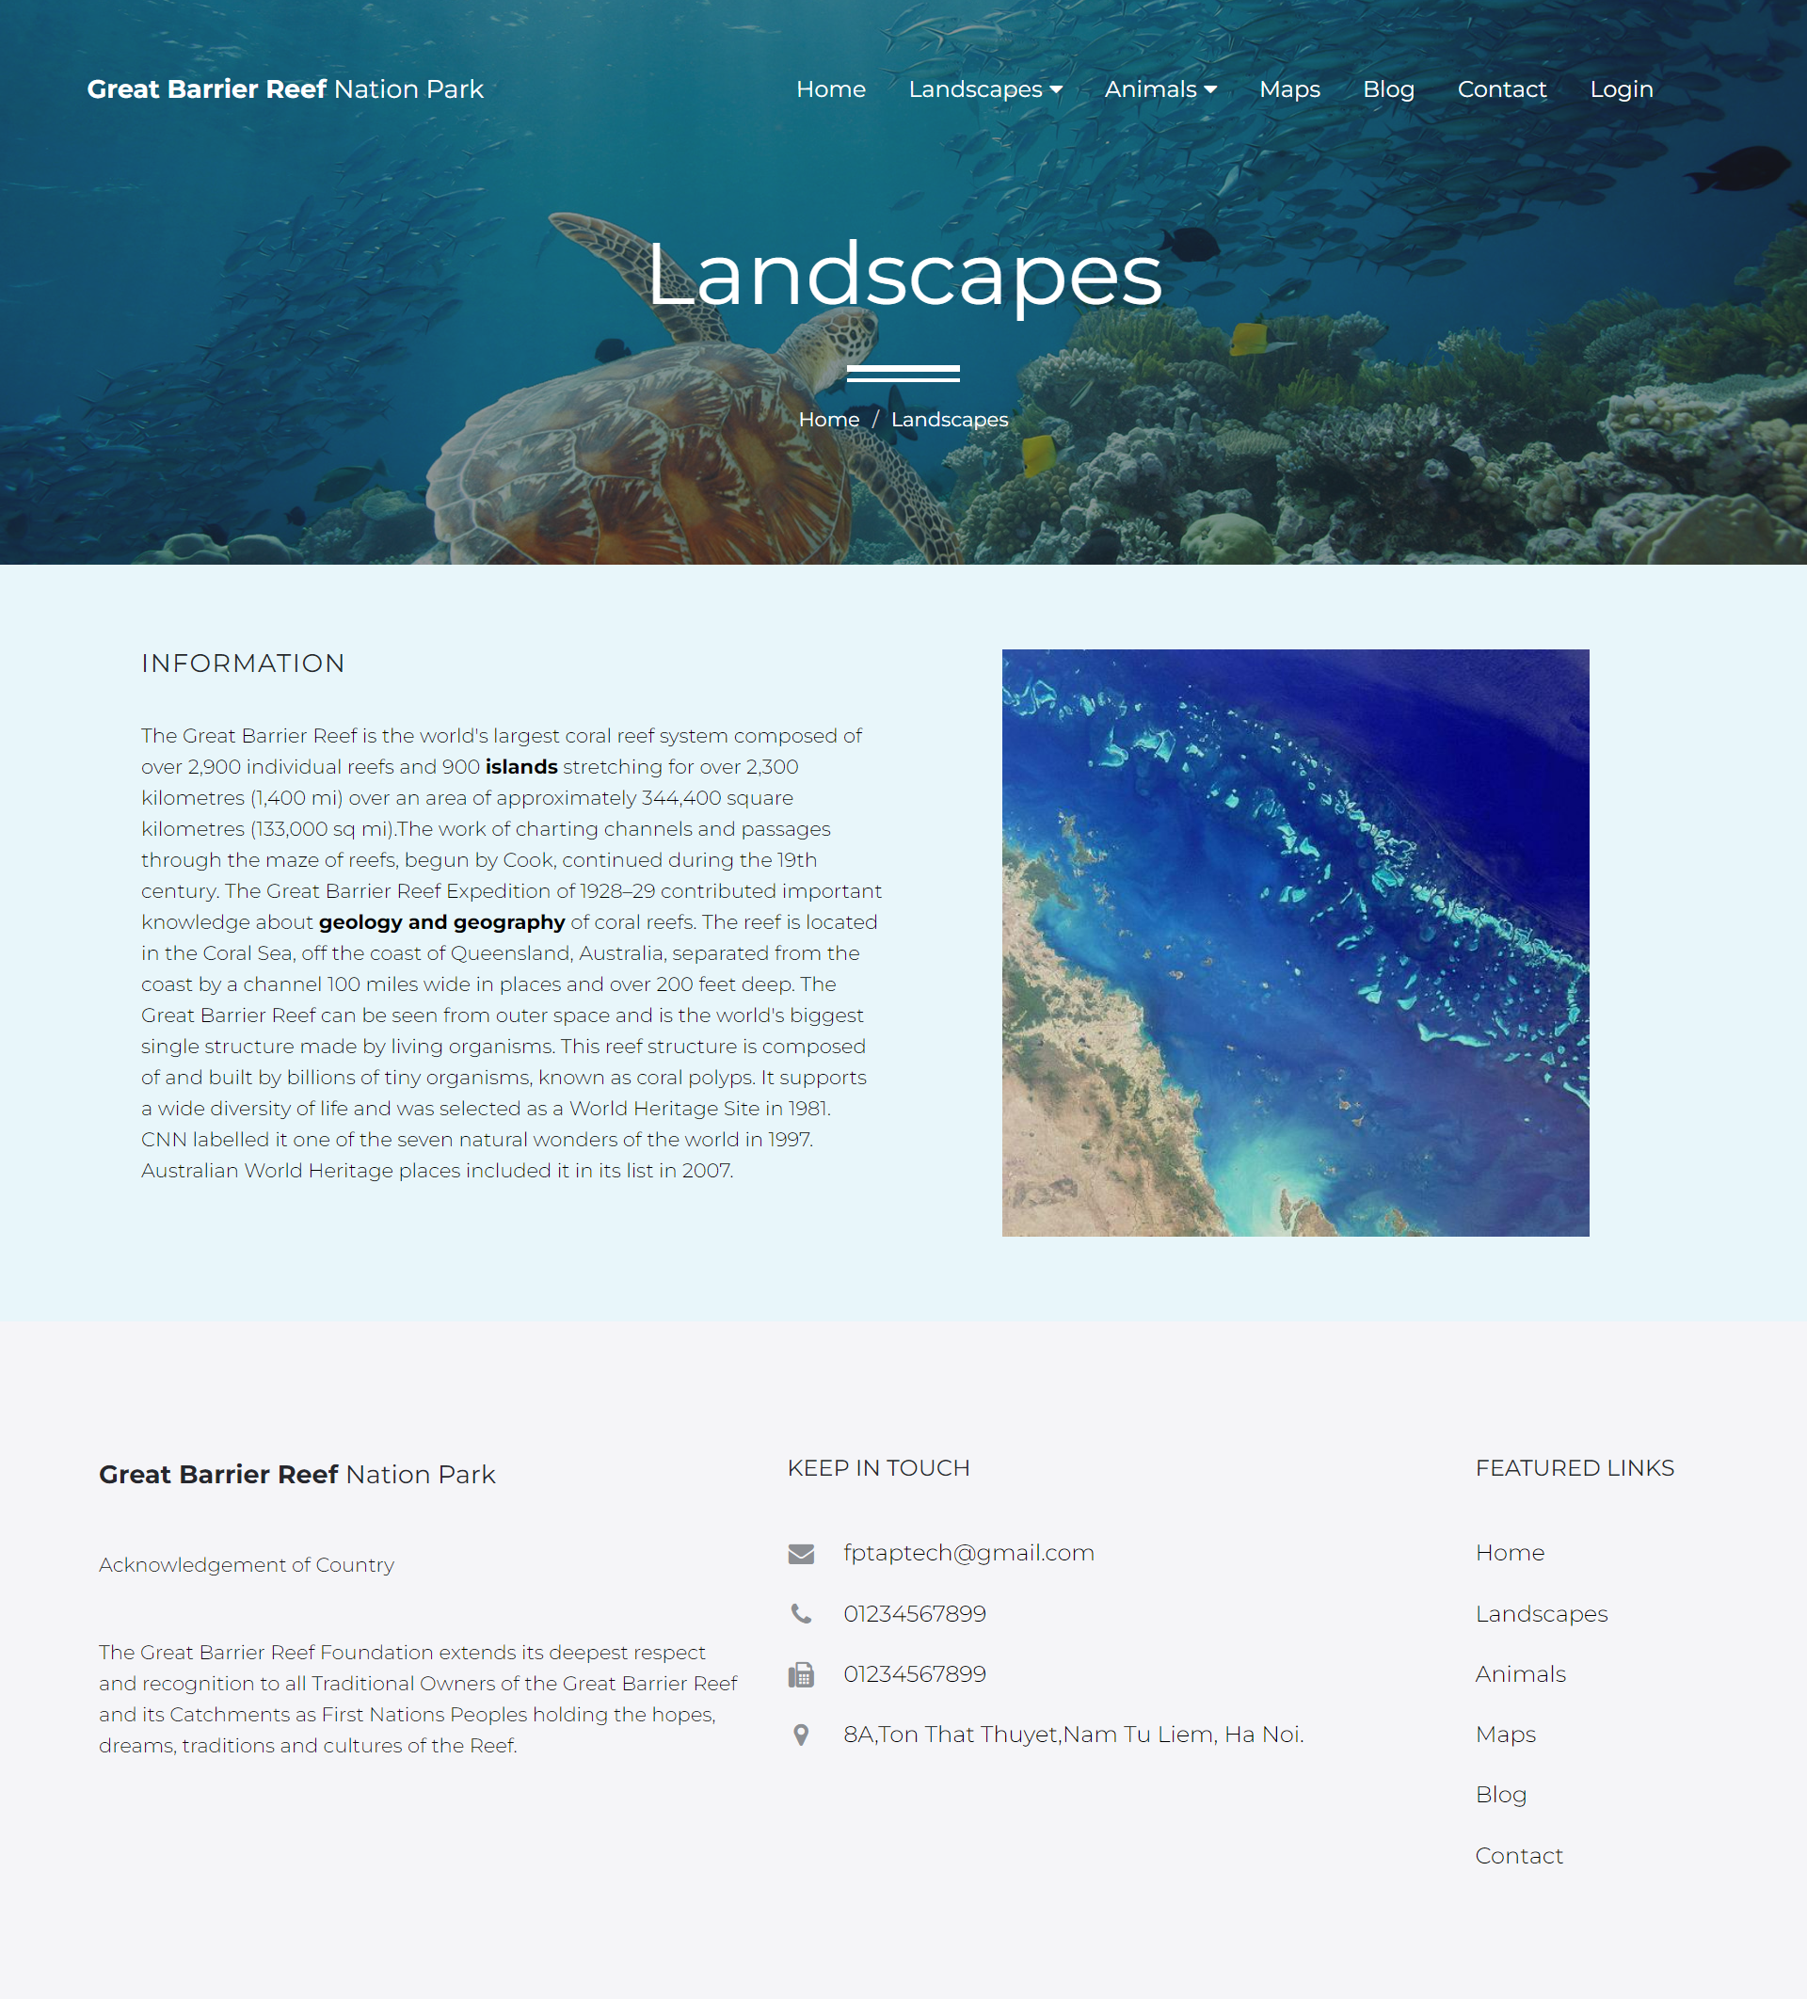

## Landscapes Detail

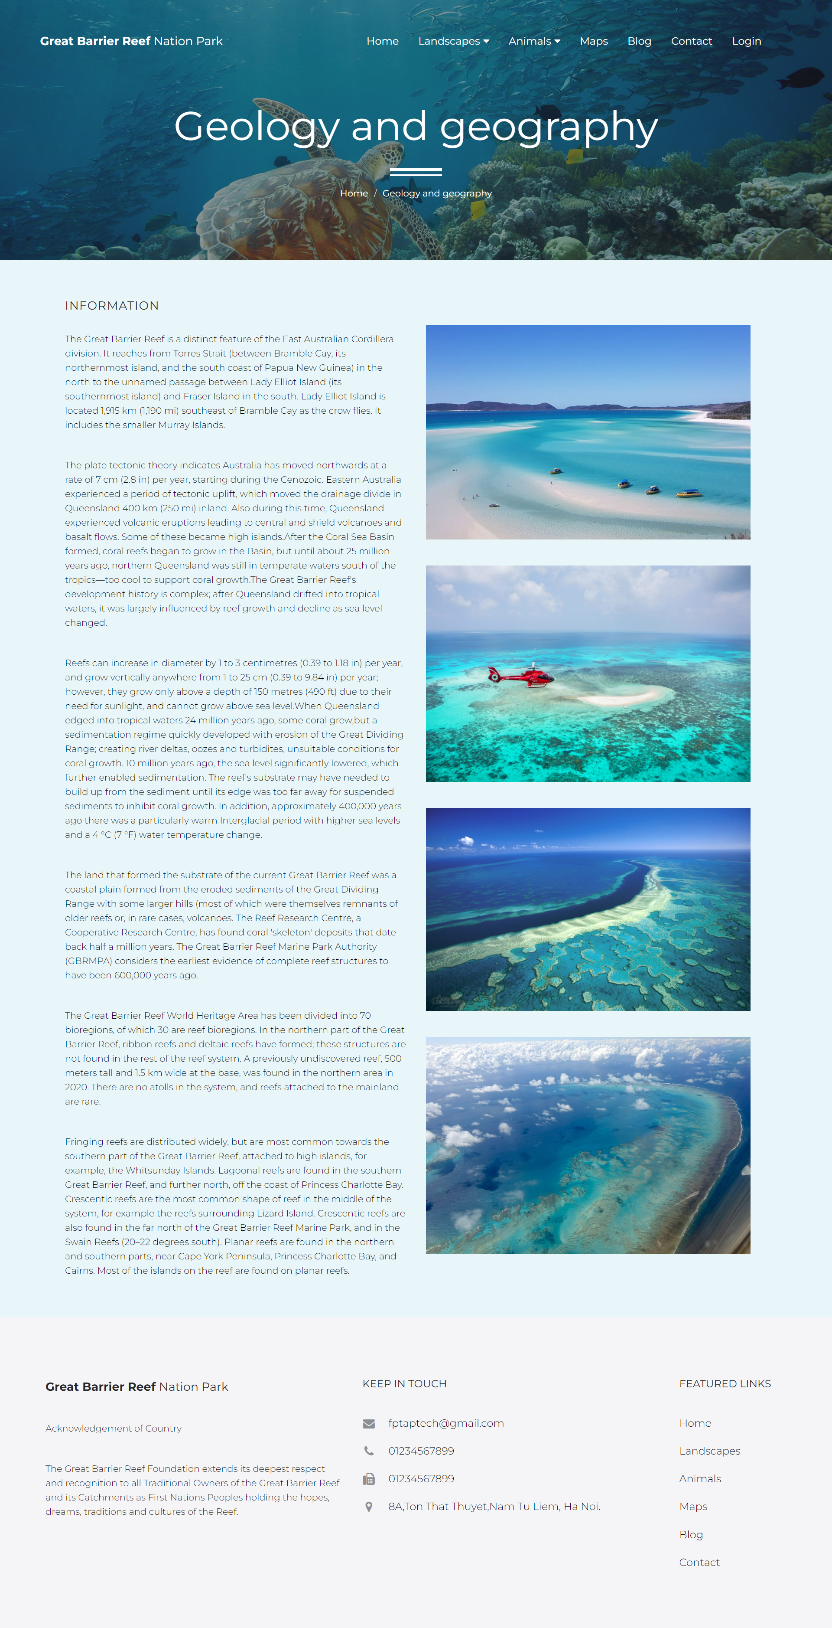

## Animals

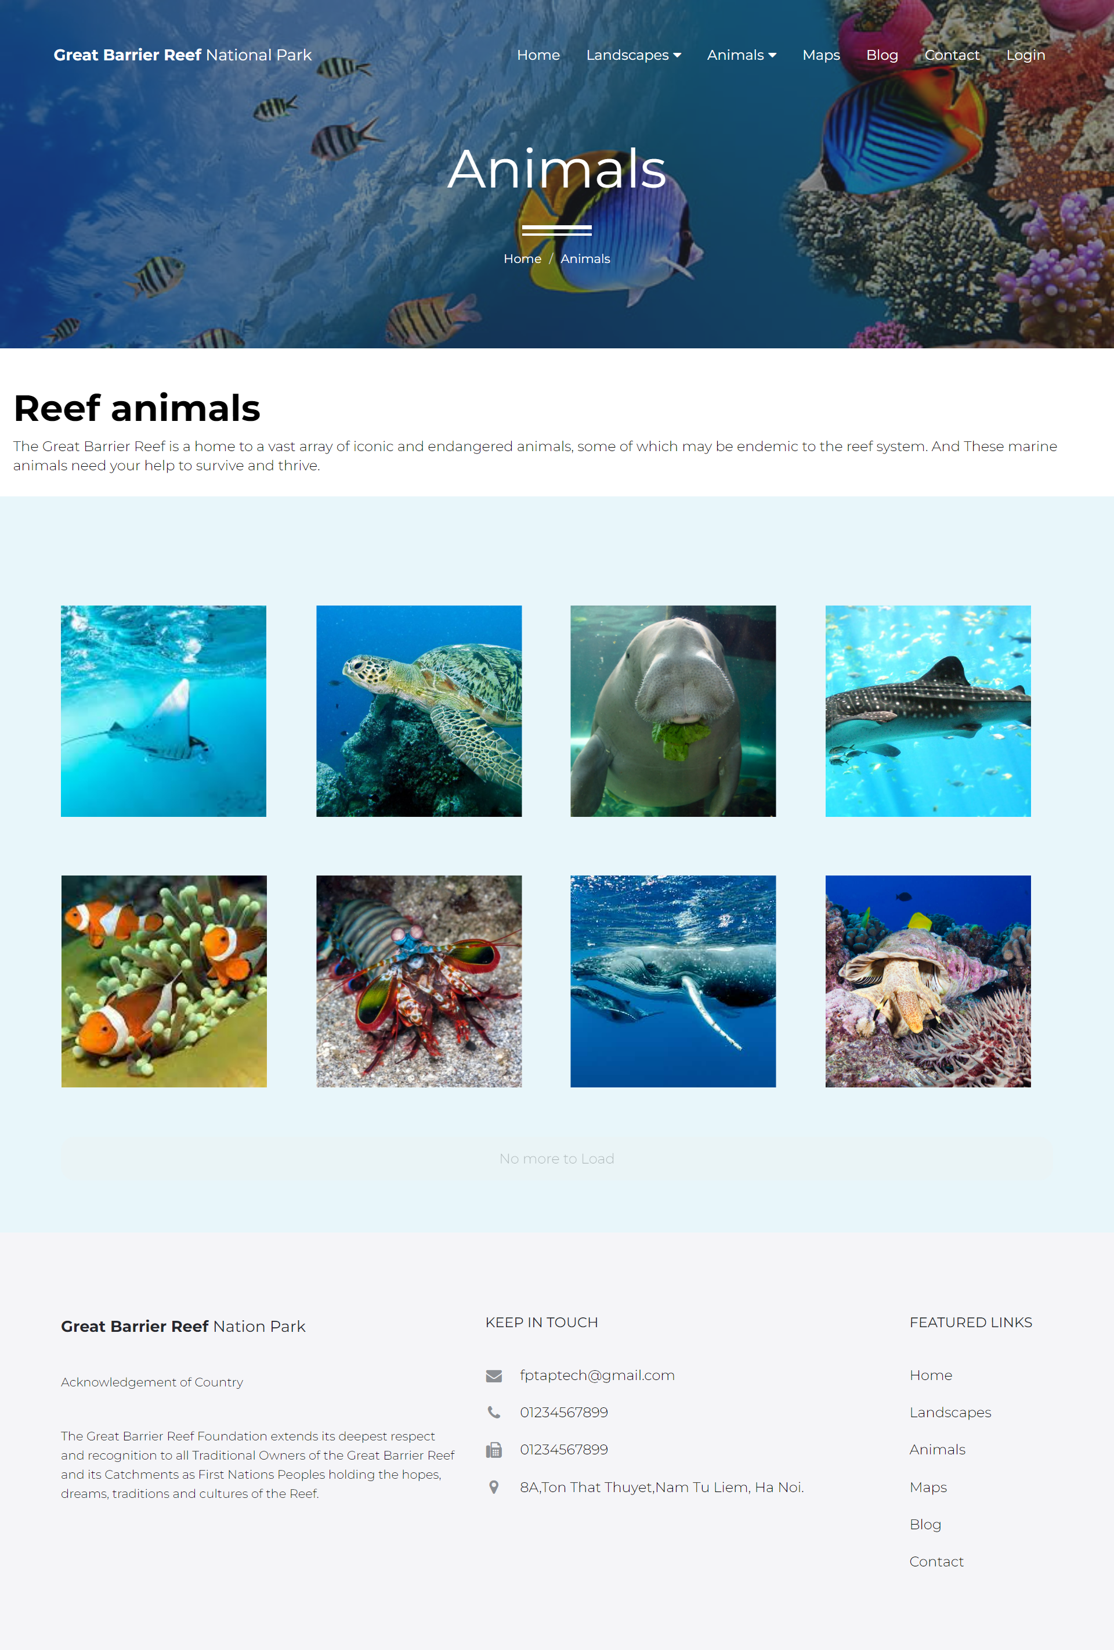

## Animals Details

## 3.6 Maps

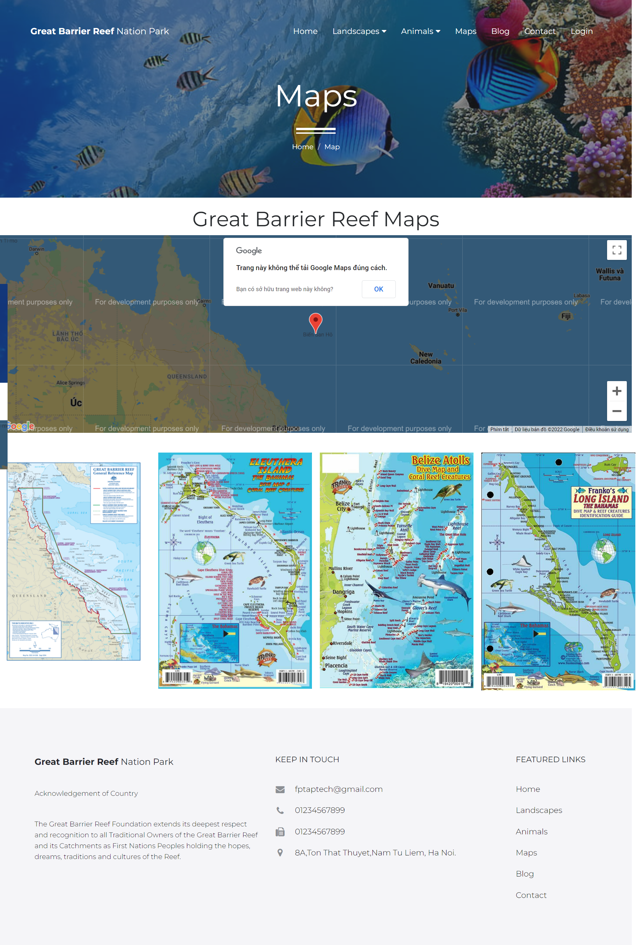

## Blog

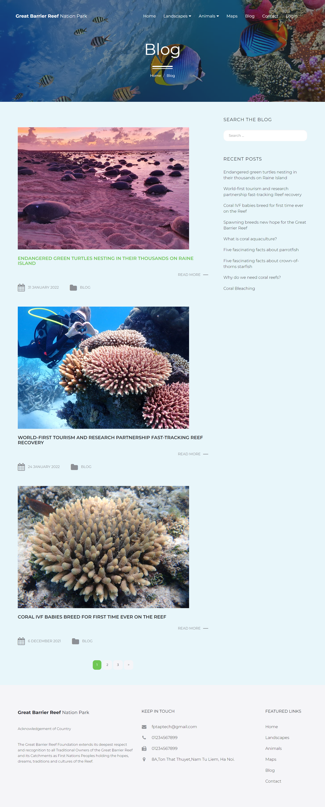

## Blog Post

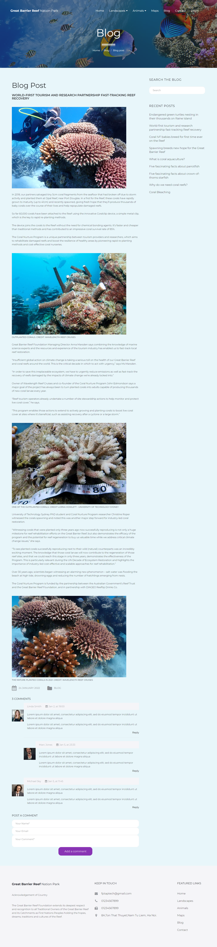

## Contact

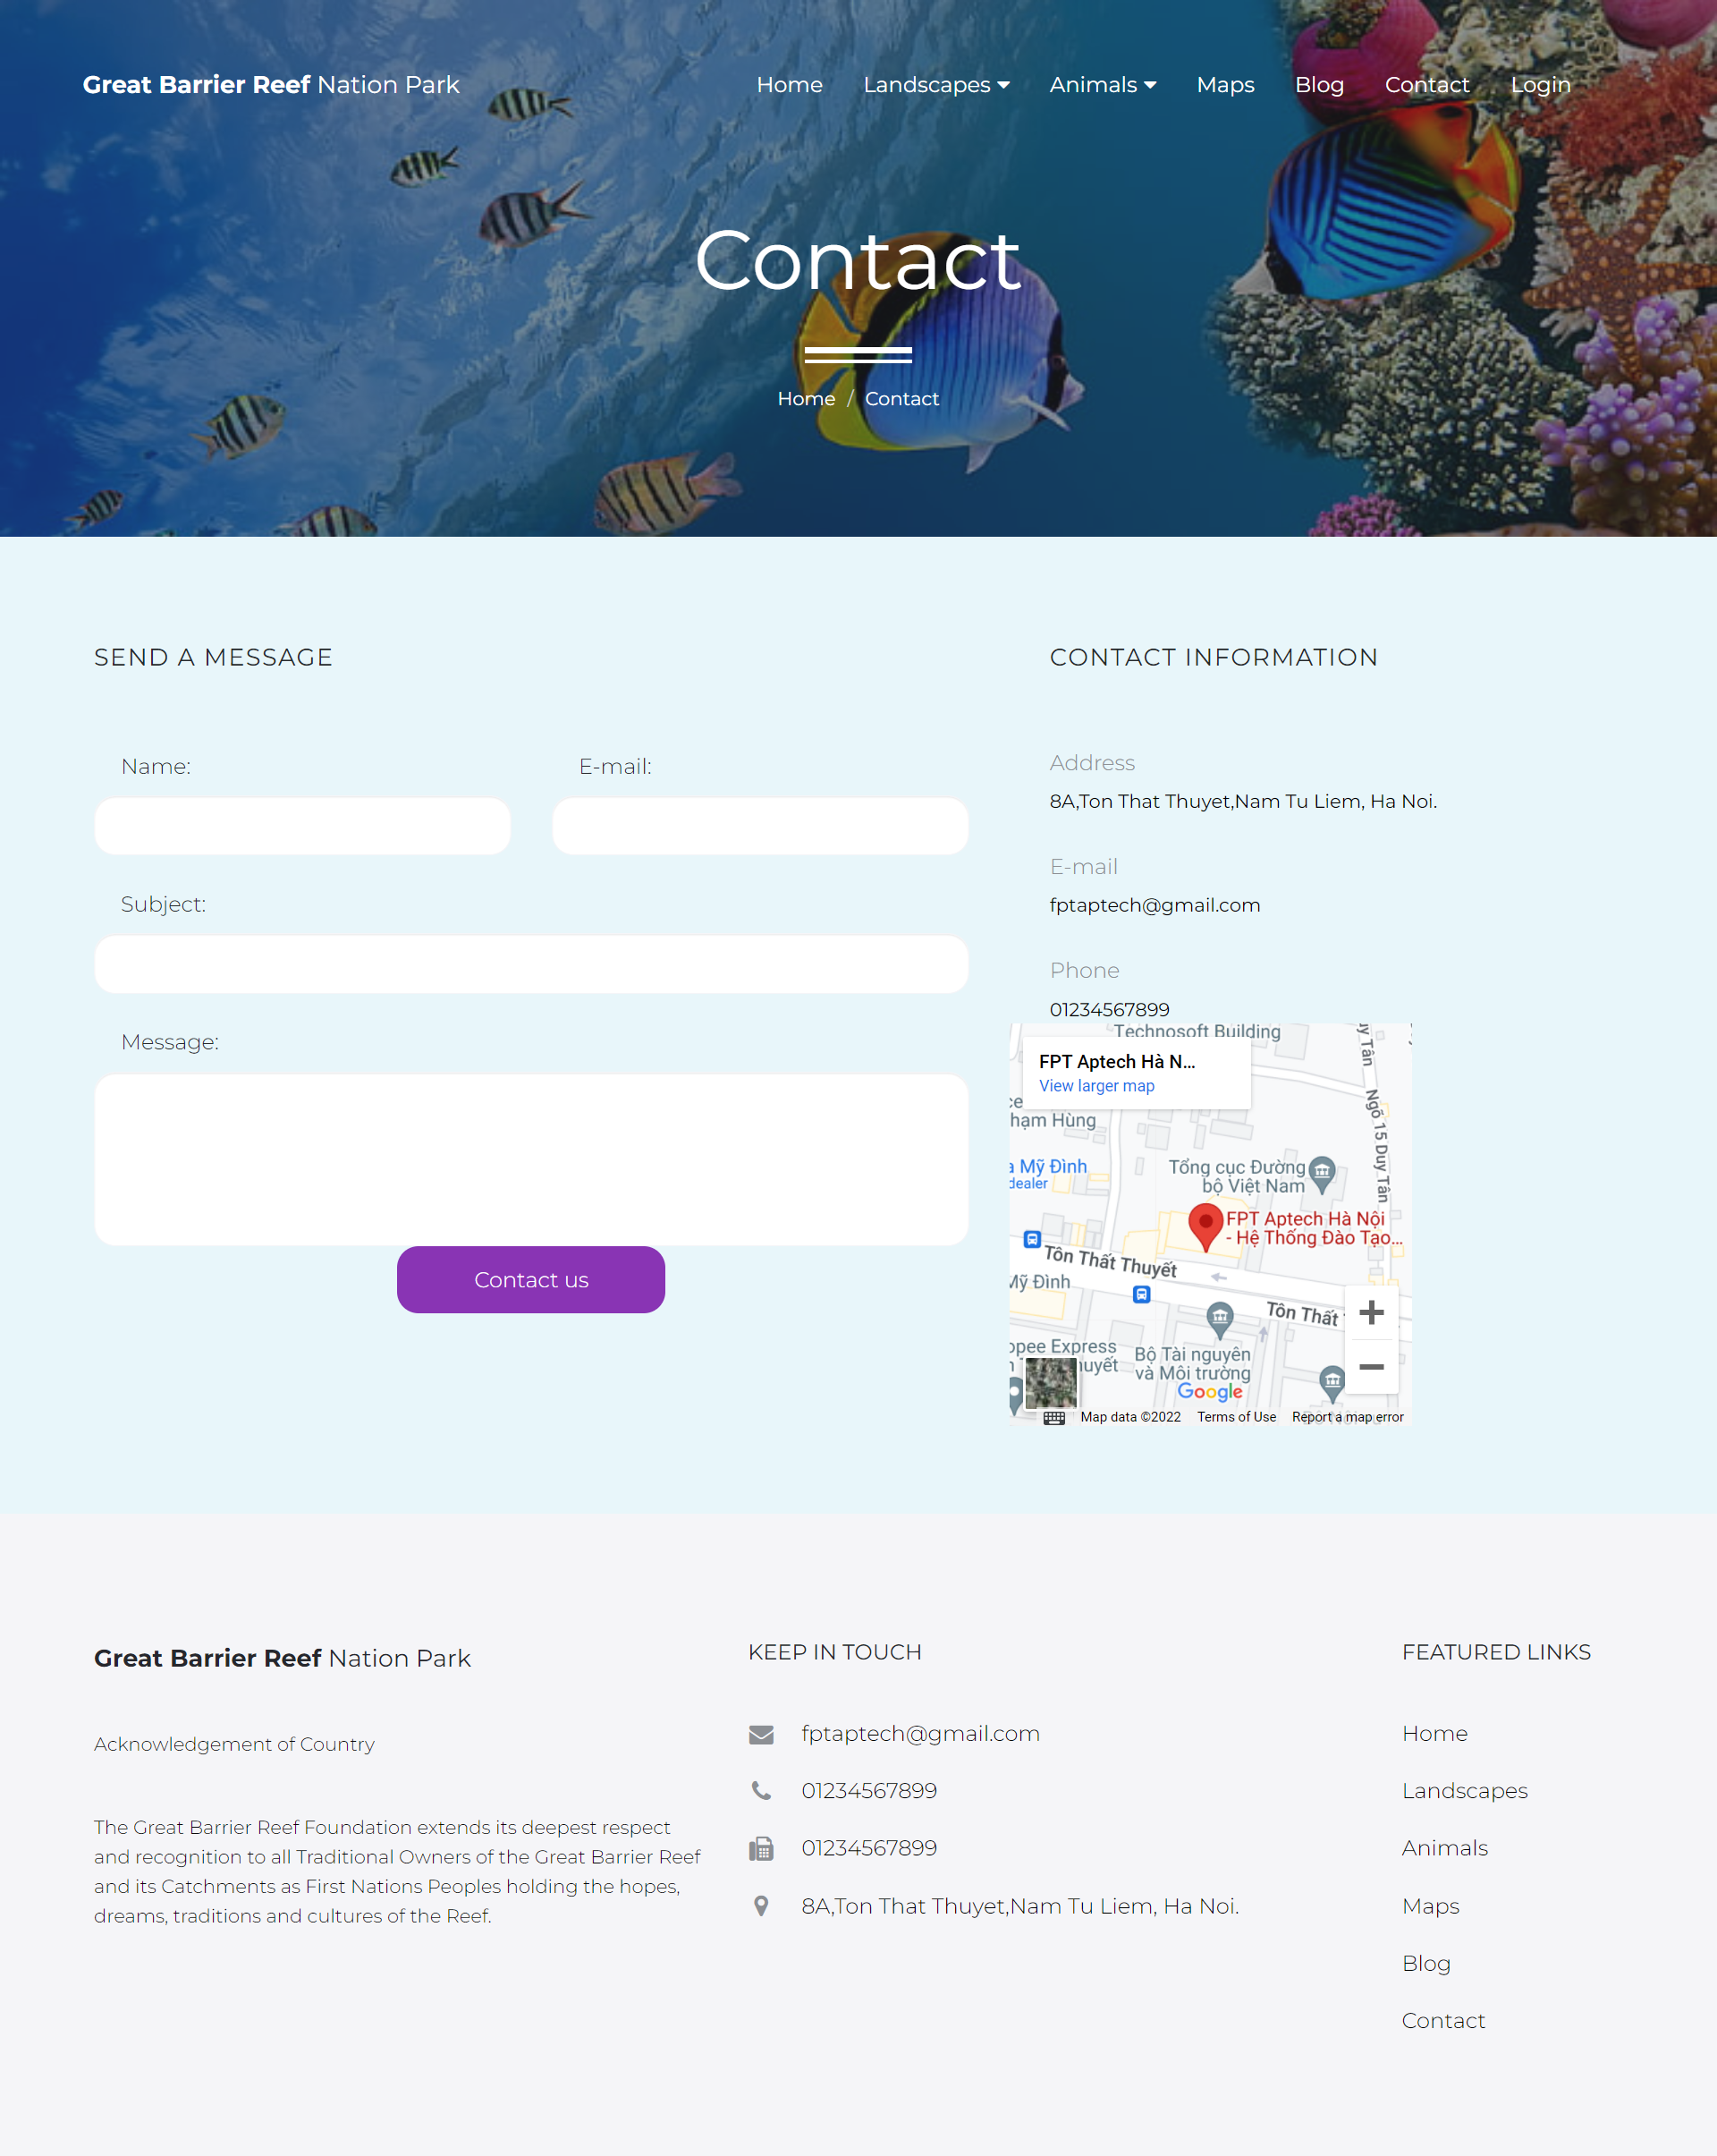

## Login

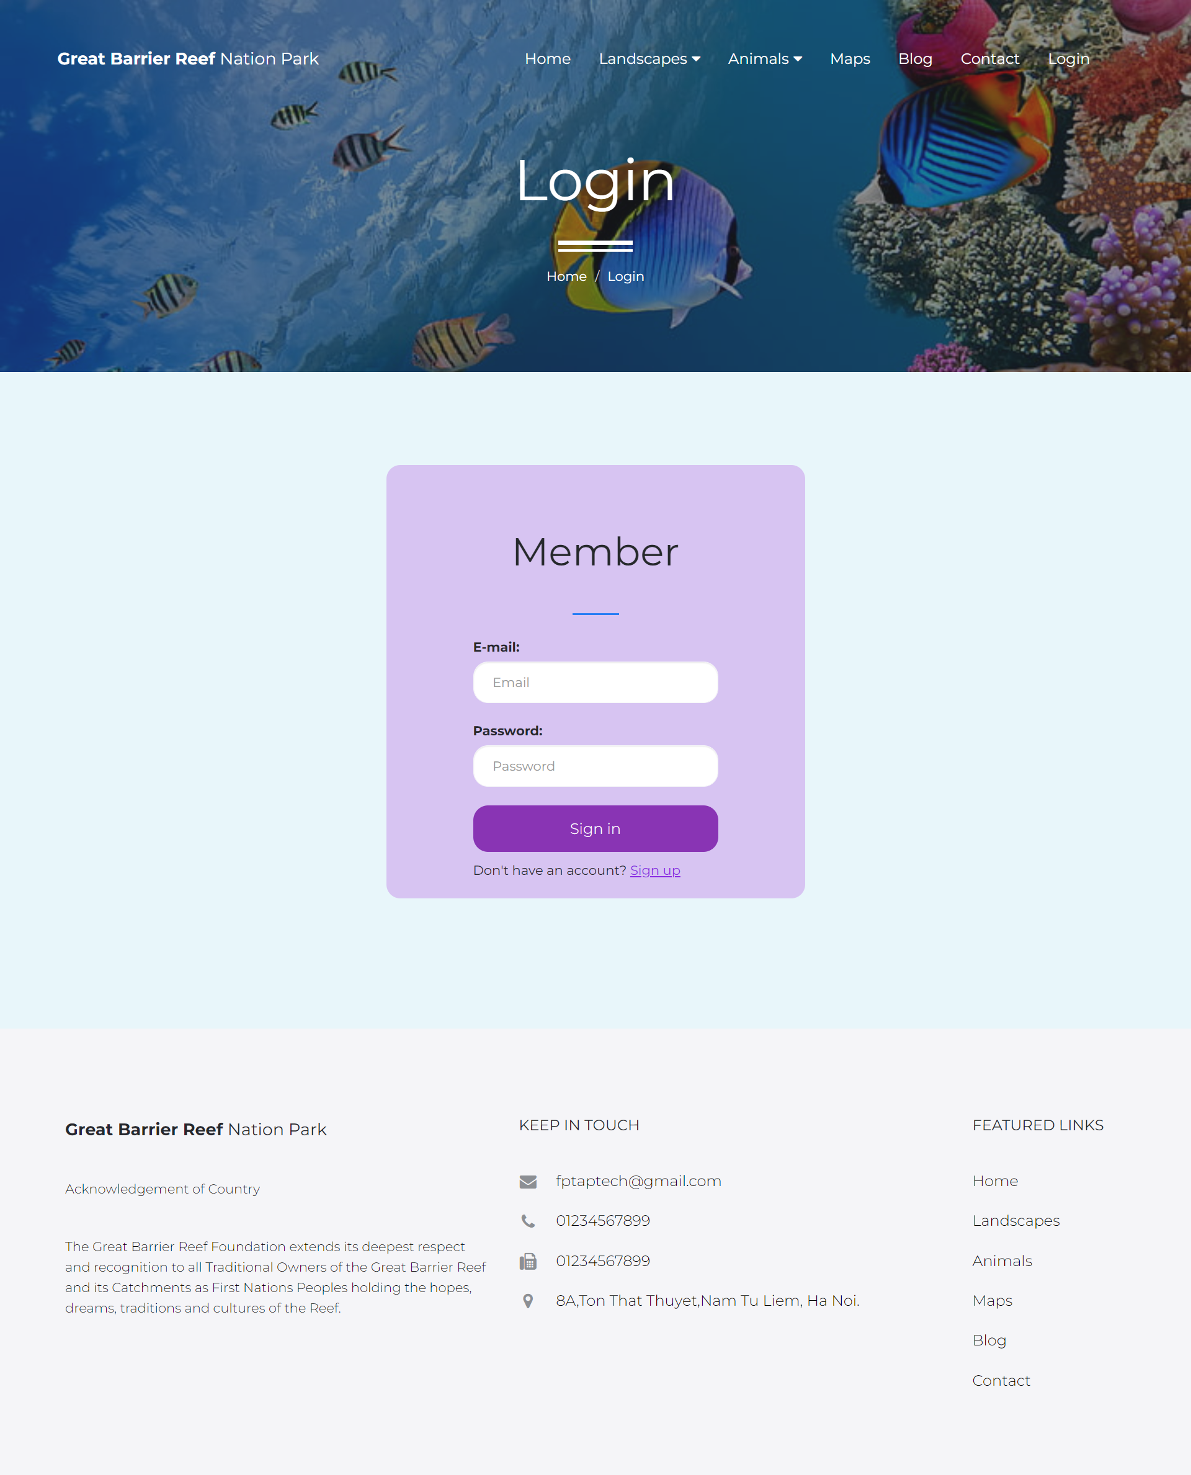

## Register

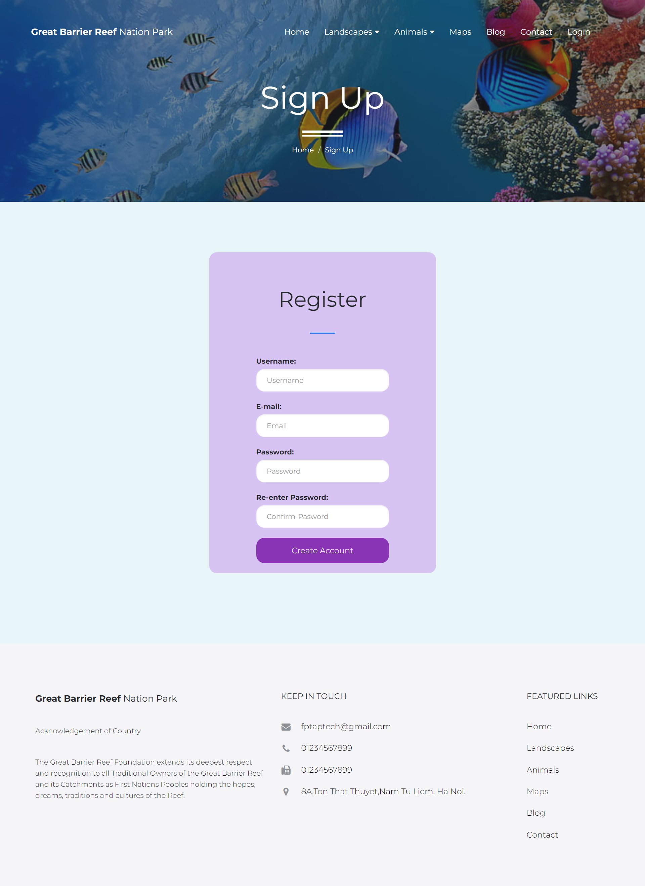

## 

## 

# Summary

The (x) means that person took part in the individual work

For instance : Nguyen Ngoc Thuy did the Homepage and Header ,...

|  |  |  |  |  |  |  |
| --- | --- | --- | --- | --- | --- | --- |
|  |  | Nguyen Ngoc Thuy |  | Nguyen Thu Thao | Nguyen Quoc Anh |  |
|  | Homepage | x |  |  |  |  |
|  | Header | x |  |  |  |  |
|  | Find resources: images and information of LEDs | x |  | x |  |  |
|  | Logo design |  |  | x |  |  |
|  | Login | x |  |  | x |  |
|  | Brands Details |  |  | x |  |  |
|  | All Brands |  |  | x |  |  |
|  | Categories |  |  | x |  |  |
|  | All Categories |  |  | x |  |  |
|  | Contact us |  |  | x |  |  |
|  | About us |  |  |  | x |  |
|  | Footer |  |  | x | x |  |
|  | Register |  |  |  | x |  |
|  | Search | x |  |  | x |  |
|  | Product Details |  |  | x |  |  |
|  | Merge Code | x |  | x |  |  |
|  | Feedback | x |  |  |  |  |